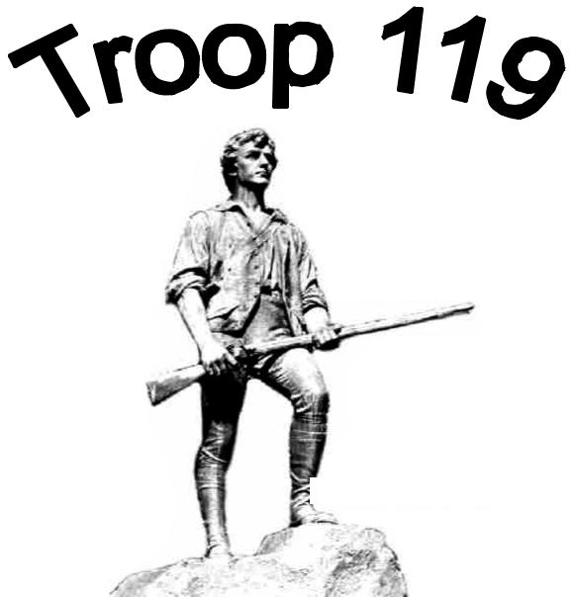
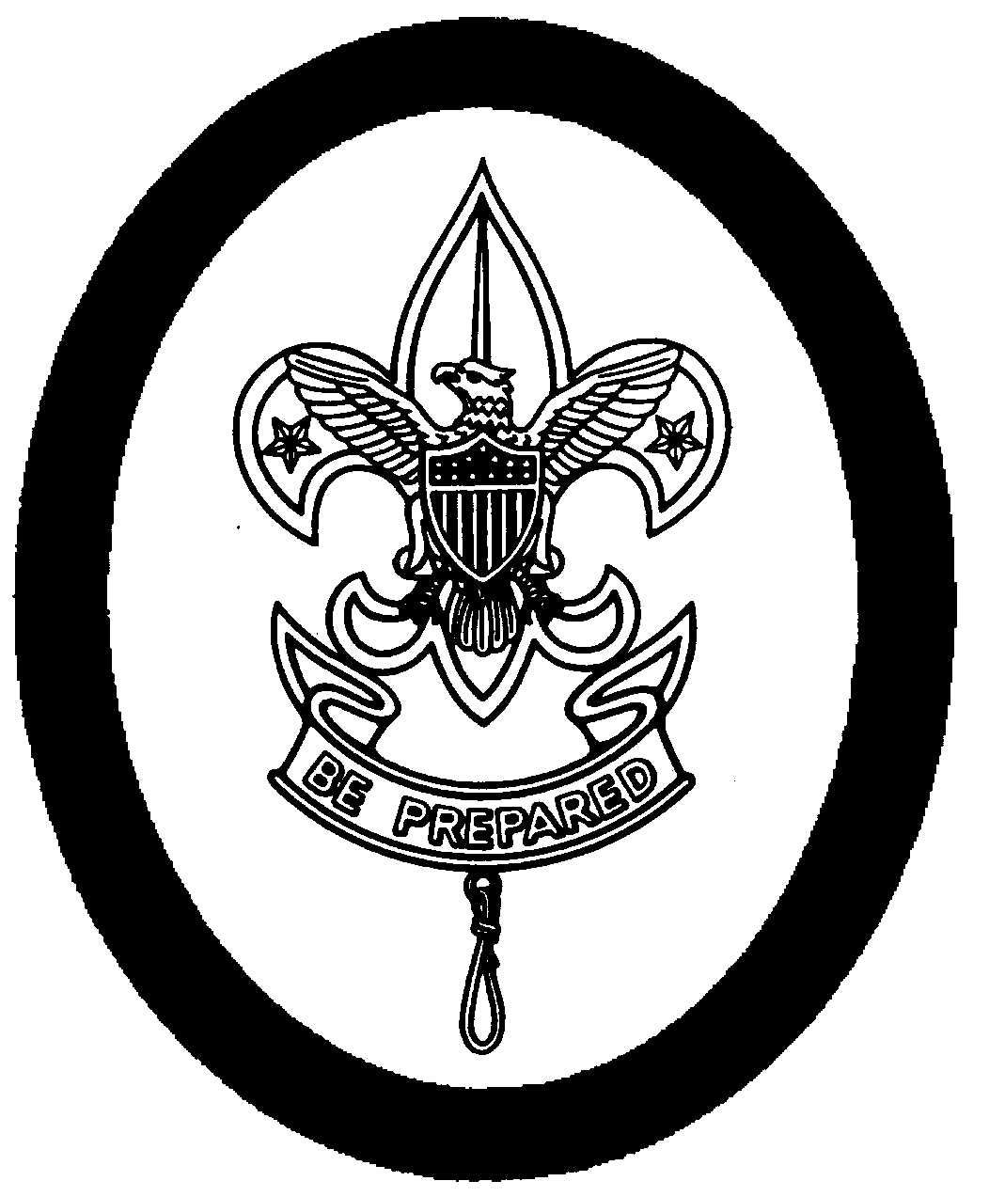
 | Scouts BSA Troop 119
Lexington, | Hancock United Church of Christ – Lexington, Massachusetts
MA | Troop Code of Conduct

As a member of Troop 119, I understand that my right to join in the fun of Scouting requires responsibility on my part to always behave according to the Scout Oath, Scout Law, Outdoor Code, the Troop 119 Scout Law Policy and the Code of Conduct described below.

The Code of Conduct for Troop 119 is as follows:

- I will not be disruptive, will pay attention and show respect to both the elected youth leaders and adult Troop Leaders.
- I will do my best to be on time and in the proper uniform for all meetings and scheduled Scouting events.
- I will participate in and support the activities of my patrol and Troop to the best of my abilities.
- I will not haze, threaten, injure or verbally abuse another person.
- I will not abuse things that belong to another person, including Troop equipment.
- I will not borrow another person’s equipment or belongings without permission.
- I will not leave a meeting, event or activity without an adult’s permission and then only with a buddy.
- I will not use profanity, drugs, alcohol, or tobacco while at any Scouting function.
- I will use matches and stick lighters only when appropriate and safe and only if I have my “Firem’n Chit.” (Cigarette lighters are not appropriate.)
- I will follow “Totin’ Chip” rules and regulations when using knives, axes, and saws.
- I will not take dangerous or unauthorized items (fireworks, firearms, bows/arrows, sling shots, laser pens, etc.) to Scouting functions.
- I will not take electronic devices to Scouting functions unless authorized by the Scoutmasters.
- I will remember that a Scout is reverent and do my best to demonstrate reverence by, for example, saying grace before all meals and attending Troop faith services.
- I will perform the duties of my office or assigned responsibility to the best of my ability.
- I will not ask another Scout to perform a task I am not willing to do myself.
- I will attempt, by word and deed, to bring honor upon my patrol, my Troop, and myself.

Consequences of Improper Behavior

The Scouts of Troop 119 elect the Senior Patrol Leaders and the Patrol Leaders to run the Troop through the Patrol Leaders’ Council (PLC). The PLC will initially address many violations of the Code of Conduct. Consequences could include a verbal warning, suspension from certain activities, removal of leadership position, referral to the Scoutmaster, or referral to the Troop Committee for severe violations, in accordance with Troop 119’s Scout Law Policy.

I will do my best to live up to the Scout Oath and Law and agree to follow this Code of Conduct.

Scout Signature__________________________________ Date: ____________________

Print name______________________________________

119 Code of Conduct

