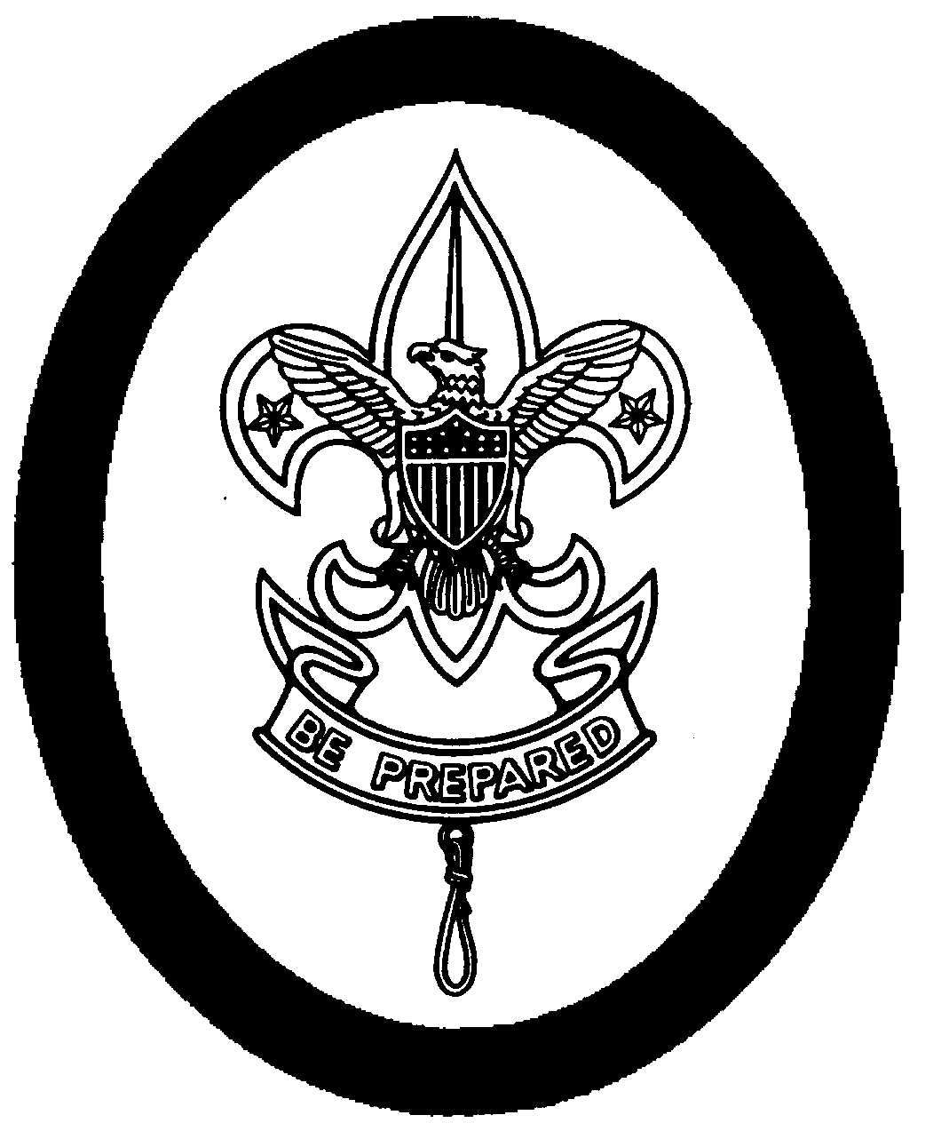
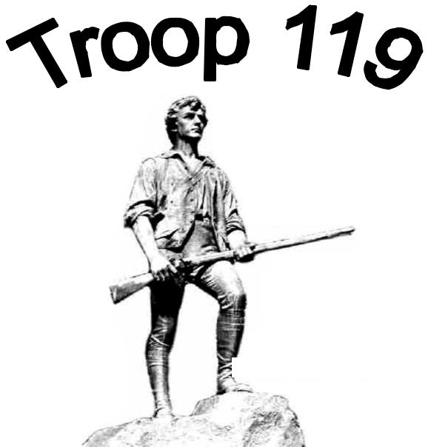

Scouts BSA Troop 119

Lexington, MA Hancock United Church of Christ – Lexington, Massachusetts

Troop 119 Scout Law Policy

Introduction

It is the policy of Troop 119 to provide a safe environment in which all members of the Troop can develop and advance within the Scouting program. Any behavior by a Scout or an Adult, that threatens the safety or well-being of another Scout, is disrespectful to youth or Adult leaders, or that brings dishonor to the Troop, Charter Organization, or the Scouting Program constitutes a serious behavior issue, which will be dealt with immediately.

This Scout Law Policy and the Troop Code of Conduct, included herein by reference, describe appropriate and inappropriate behavior, processes for implementing the policy and the possible consequences of inappropriate behavior. All Scouts are required to provide the Troop with a Policy signed by the Scout and his/her parent(s) or guardian(s).

Behavior

- All Scouts and Adults are expected to live, to the best of their ability, by The Scout Oath and Law, which says that a Scout is Trustworthy, Loyal, Helpful, Friendly, Courteous, Kind, Obedient, Cheerful, Thrifty, Brave, Clean and Reverent.

- The Troop Code of Conduct is the commitment we each make to each other to be respectful and to do our best to support the principles and values of Scouting.

- Properly wearing the Scout uniform is a core value and compliance with the Troop uniform policy is required of all Scouts. Class A is the appropriate attire for all Troop meetings, Courts of Honor, Scoutmaster Conferences, Boards of Review, and other formal events. The PLC will determine appropriate attire for other events and activities but will generally require a Class B uniform.

- Conduct that will not be tolerated includes: fighting; hazing; threatening; verbal abuse of other Scouts or Scout leaders; harassment of other Scouts or Scout leaders; habitual use of foul language; use of tobacco in any form; use of drugs; consumption of alcohol; inappropriate use of knives, axes, saws or other sharp objects; careless use of flammable products and fire; abuse of Troop property; abuse of the personal equipment and property of others; and any other conduct in which the Scout engages which the Scoutmaster and Assistant Scoutmasters believe threatens the well-being of the Scout or others, Troop property or the property of others, or interferes with the purposes of Scouting.

- Disruptive behavior in meetings and at events or activities is disrespectful to others and is not supportive of the Troop and Patrol activities and the Scouting program and will not be tolerated.

6/16/06 119 Scout Law Policy - 1
- The attempt of any Scout to frighten, coerce, or force another Scout into taking or being subjected to any action(s) that would otherwise be against his/her will is strictly prohibited.

- Adults should be a positive role model for Scouts, provide instruction in a constructive and supportive manner, and create an environment that encourages learning, tolerates failure and strives to promote the principle of a Scout-led Troop. Adults should seek to learn, through formal training and hands-on experience, the skills necessary to provide instruction and guidance to Scouts.

- Adults must be trained and practice the principles of the Boy Scouts of America Youth Protection Program.

- Corporal punishment of any kind is not tolerated in Scouting.

Responsibilities and Consequences

- The Patrol Leaders’ Council (PLC) is the elected body of a Scout-led Troop and may deal with a Scout’s or Troop conduct problems assigned to it by an Adult leader or take on issues on their own with permission and guidance from the Scoutmaster or an Assistant Scoutmaster. The PLC may meet anywhere, any time. The PLC must consider all sides of a problem, discuss the issue, and recommend to the Scoutmaster (or Adult leader in charge of the event if immediate action is required) what action should be taken. The Scoutmaster will review the decision of the PLC, and, at his or her discretion, will enforce either that decision or suggest a modified version of the decision.

- The PLC and the Scoutmaster may consider one of several action steps or consequences:

  - A verbal warning.

  - A one-on-one or group meeting with the Scout to review appropriate behavior.
  - Loss of privileges to attend or participate in a Troop activity or event for more serious or repeat offenses.
  - Removal of a Scout from his/her leadership position.
  - Assignment of a work or service project that provides a tangible benefit for the Troop and is consistent with the infraction. The project must be completed immediately and before a Scout can advance to the next rank.
  - Referral to the Troop Committee for further action.

- The Scoutmaster or an Adult, in consultation with another Adult leader, will deal with minor problems in the manner that they determine to be in the best interest of the Scout and the Troop, which shall be appropriate for the situation and consistent with Scout policy. More serious situations shall be dealt with in the following manner:

  - When the behavior of a Scout could threaten the safety of another individual, or is felt to be sufficiently serious, any Adult leadership should take immediate action using their best judgment.

  - In the case of a serious problem, such as a safety issue or insubordination to a leader, the youth or Adult leader must first stabilize the situation and inform the Scout that s/he is “on report.” The leader should then “step back” and immediately involve another Adult, preferably the Scoutmaster, as to the handling of the situation.

6/16/06 119 Scout Law Policy - 2
  - As a consequence of a serious infraction on any activity or event, the Scoutmaster or Adults may decide to send a Scout home, in which case the parents should come as quickly as possible, and any expenses resulting from the Scout being sent home will be borne solely by the parents of the Scout.

  - The Troop Committee will be advised of any instance of serious misconduct, as will the parents of the affected Scout.

- The Troop Committee has the primary responsibility for the safe, effective and efficient operations of Troop 119 and, therefore, has the final authority to deal with all violations of the Troop 119 Code of Conduct and Scout Law Policy. Generally, the Committee, the Scoutmaster and other Adult leaders will operate on a “three strikes” approach. The first strike is a warning. The second strike is a serious warning where the Committee may choose to contact the Scout’s parents. The third strike means “you’re out” and is only exercised as a last resort after all attempts to reach a satisfactory resolution have been exhausted.

- The Troop Committee should be immediately notified of any reports of inappropriate behavior by Adults associated with the Troop and will have primary responsibility for investigating the circumstances and taking appropriate action.

- In order to assure the safety of all Scouts and the well-being of the Troop, the Troop Committee reserves the right to do any or all of the following:

  - Provide guidance to the PLC and Scoutmaster with regard to handling the specific situation which may include any of the remedies mentioned earlier.

  - Revoke a Scout’s privilege to participate in meetings and activities.
  - Delay advancement for not living up to the spirit of the Scout Oath and Law.
  - Invite the parents of the Scout and the Scout to meet with representatives of the Committee and the Scoutmaster to discuss the situation and to attempt to reach a satisfactory conclusion.

  - Suspend a Scout from the Troop for a defined period of time.
  - Terminate membership in the Troop but only after the parents of the Scout and the Scout have been invited to attend a Committee meeting to discuss the issue of termination. If parents choose not to attend the termination meeting, the Scout’s participation in the Troop will be immediately terminated. It is the goal of the Troop that termination from the Troop is a “last resort” which is reserved for severe problems and undertaken only to assure the safety of the Scout membership and the well-being of the Troop

Read and Understood:

Scout: _____________________________ Parent: _____________________________

Print name: _________________________ Print name: ___________________________

Date: ______________________________

6/16/06 119 Scout Law Policy - 3

